AWS WAF (Web Application Firewall)

What is AWS WAF?
Amazon Web Services AWS WAF (Web Application Firewall) is a security service used to protect web
applications from common web exploits and attacks.
It filters and monitors HTTP/HTTPS traffic between users and your web application.
Why AWS WAF is Used
AWS WAF helps protect applications from:
- SQL Injection (SQLi)
- Cross-Site Scripting (XSS)
- DDoS Layer 7 attacks
- Bot traffic
- IP spoofing
- Malicious requests
- Rate-based attacks
AWS WAF Works With
AWS WAF can be attached to:
- Amazon CloudFront
- Application Load Balancer (ALB)
- Amazon API Gateway
- AWS AppSync
- Amazon Cognito
Components of AWS WAF
1. Web ACL (Access Control List)
A Web ACL is the main container where rules are added.
It decides whether requests are:
- Allow
- Block
- Count
- CAPTCHA / Challenge
2. Rules
Rules inspect web requests.
Types of Rules
- Managed Rules
- Custom Rules
- Rate-based Rules
- IP Set Rules
- Geo Match Rules
3. Rule Groups
Collection of multiple rules.
Example:
- AWS Managed Rule Group
- Custom Security Rule Group
4. IP Sets
Used to allow or block specific IP addresses.
Example:
- Block malicious IPs
- Allow office public IPs
5. Regex Pattern Sets
Used for matching specific patterns in requests.
Example:
- Block special characters
- Detect suspicious URLs

Types of AWS WAF Rules
AWS Managed Rules
Predefined rules maintained by AWS.
Examples:
• Core Rule Set
• SQL Database Protection
• Linux Protection
• PHP Protection
Benefits:
• Easy to deploy
• Automatically updated
Custom Rules
Rules created manually by users.
Example:
• Block requests from a country
• Allow only company IP addresses
Rate-Based Rules
Blocks IPs sending too many requests.
Example:
• More than 1000 requests in 5 minutes
Useful against:
• Brute-force attacks
• HTTP flood attacks
Example Architecture
Users
↓
CloudFront / ALB
↓
AWS WAF
↓
Web Application
How AWS WAF Processes Requests
1. User sends request
2. WAF checks Web ACL rules
3. Rules evaluate request
4. Action is taken:
o Allow
o Block
o Count
o CAPTCHA

Steps to Create AWS WAF
Using AWS Console
1. Open AWS Console
2. Go to AWS WAF
3. Create Web ACL
4. Select Resource
o ALB
o CloudFront
o API Gateway
5. Add rules
6. Set default action
7. Review and create

Create EC2 instance

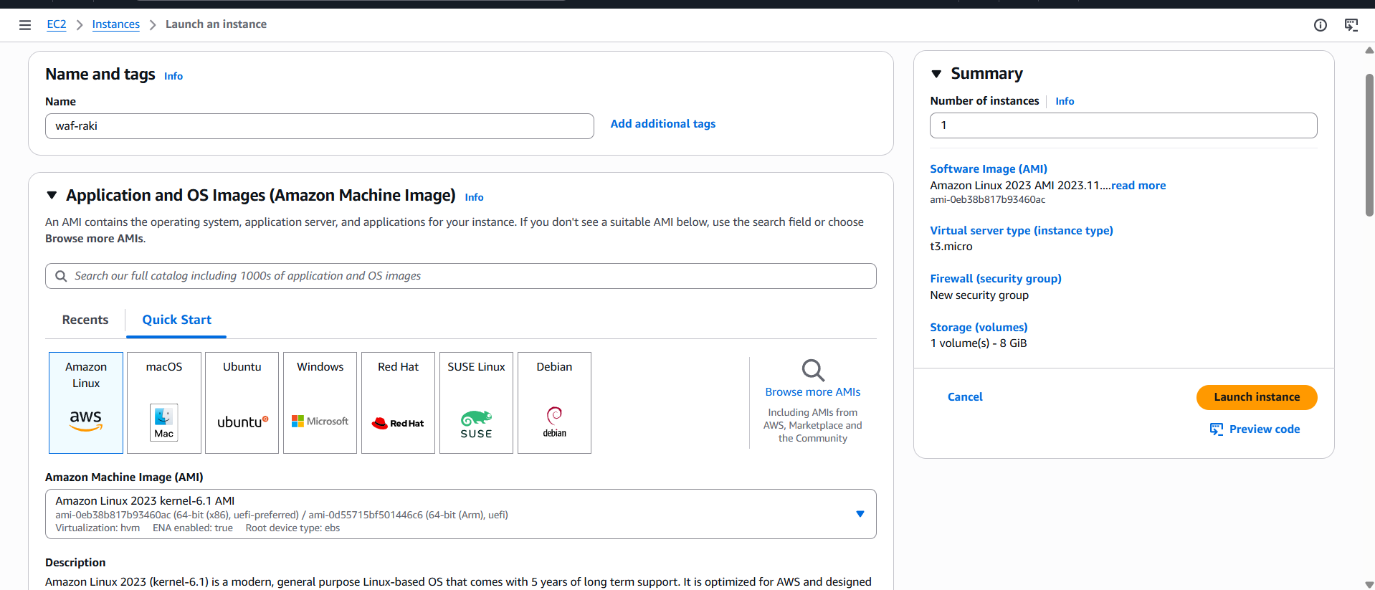
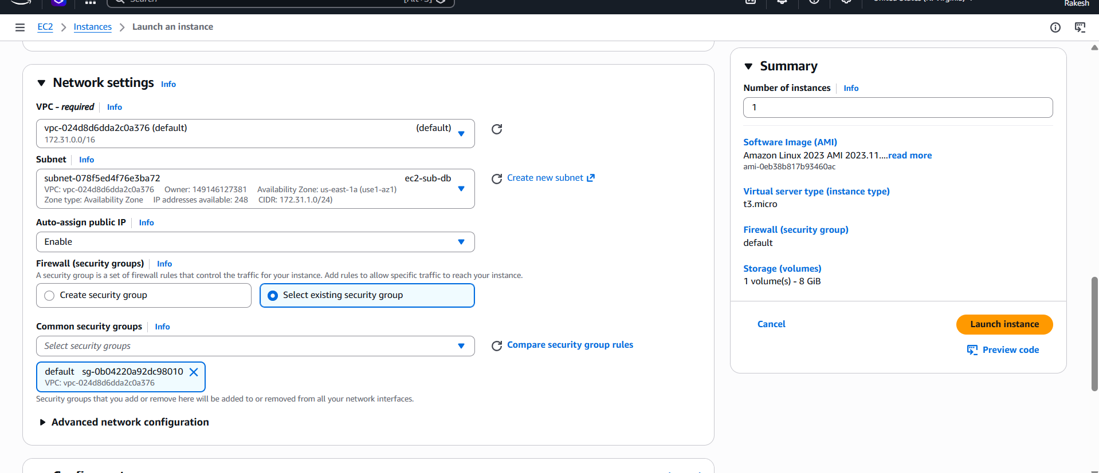
Instance created
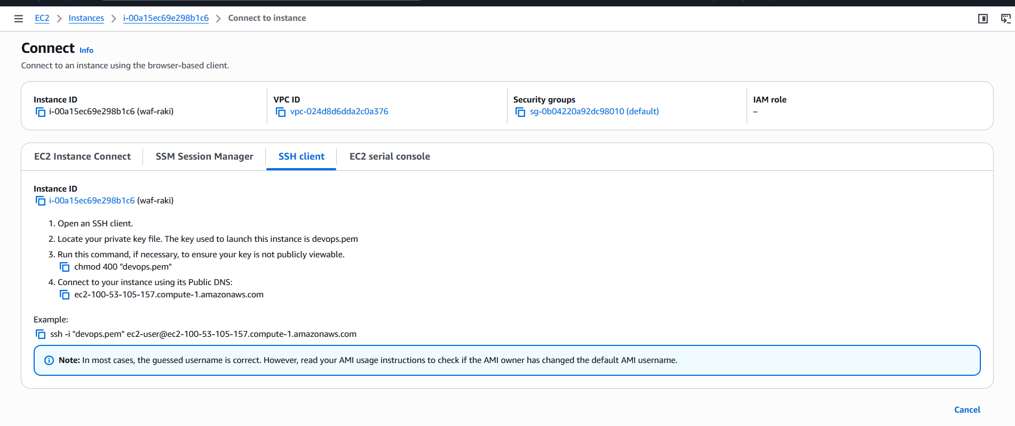
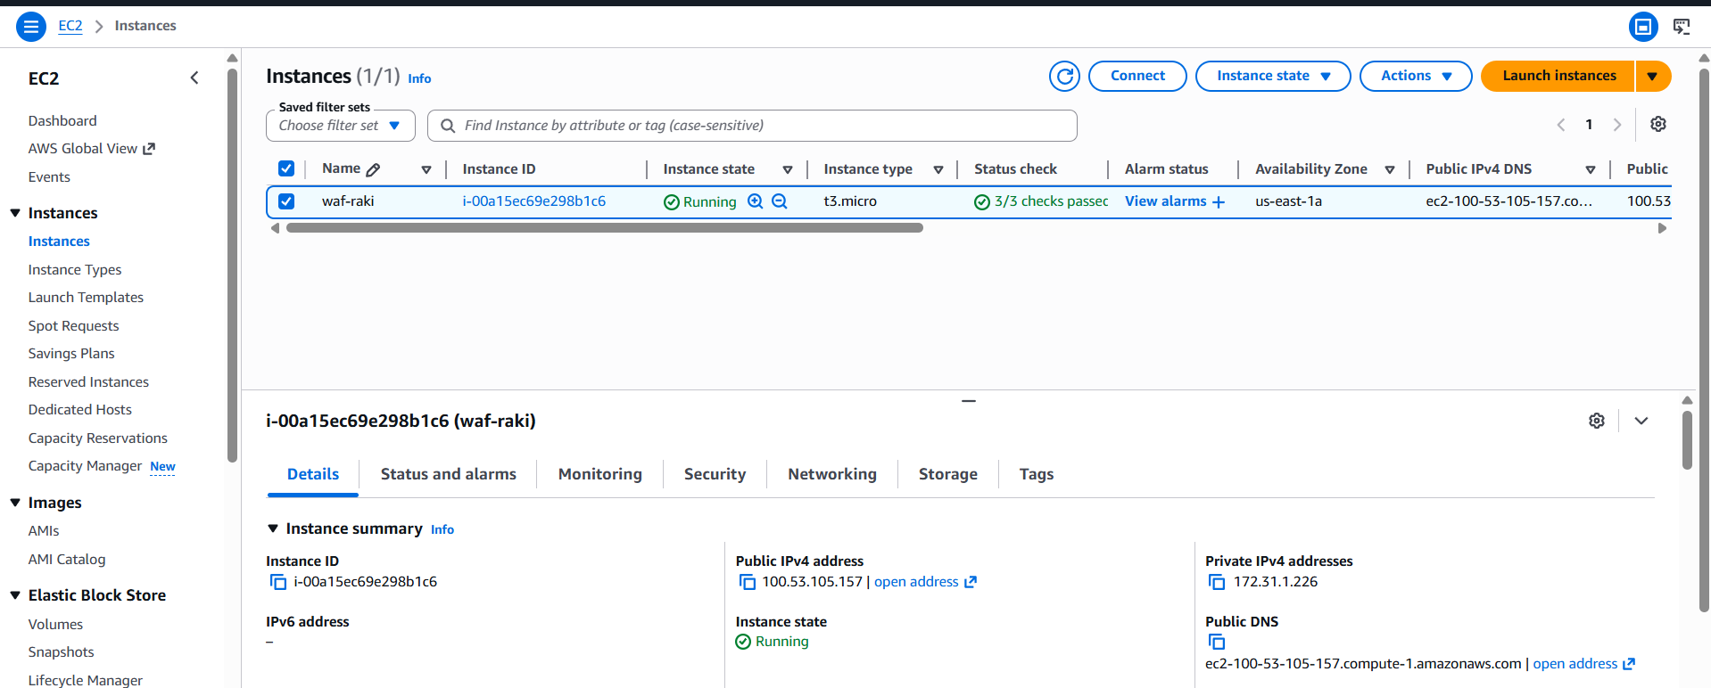

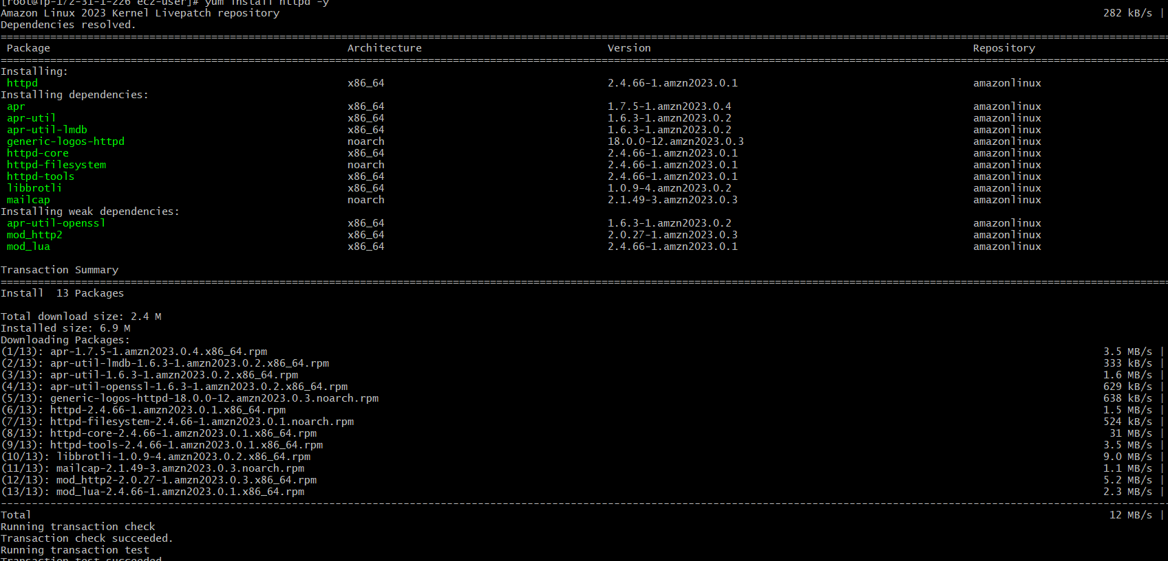

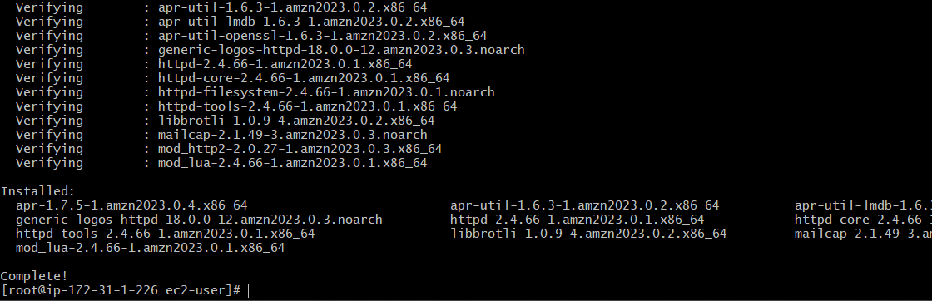
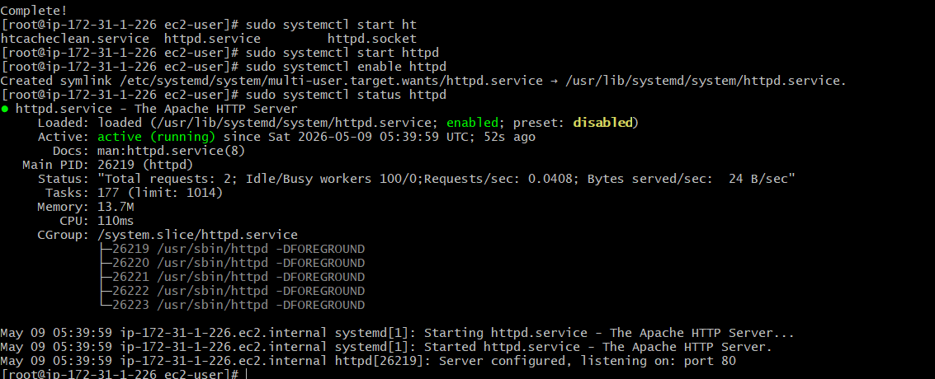
Verified in browser and its working
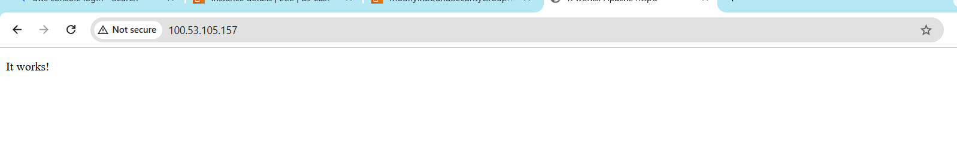
Create a target group
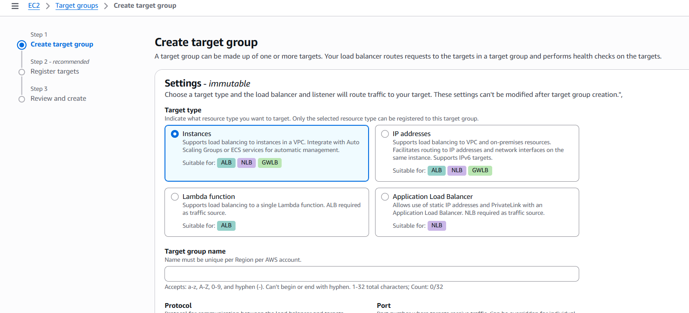
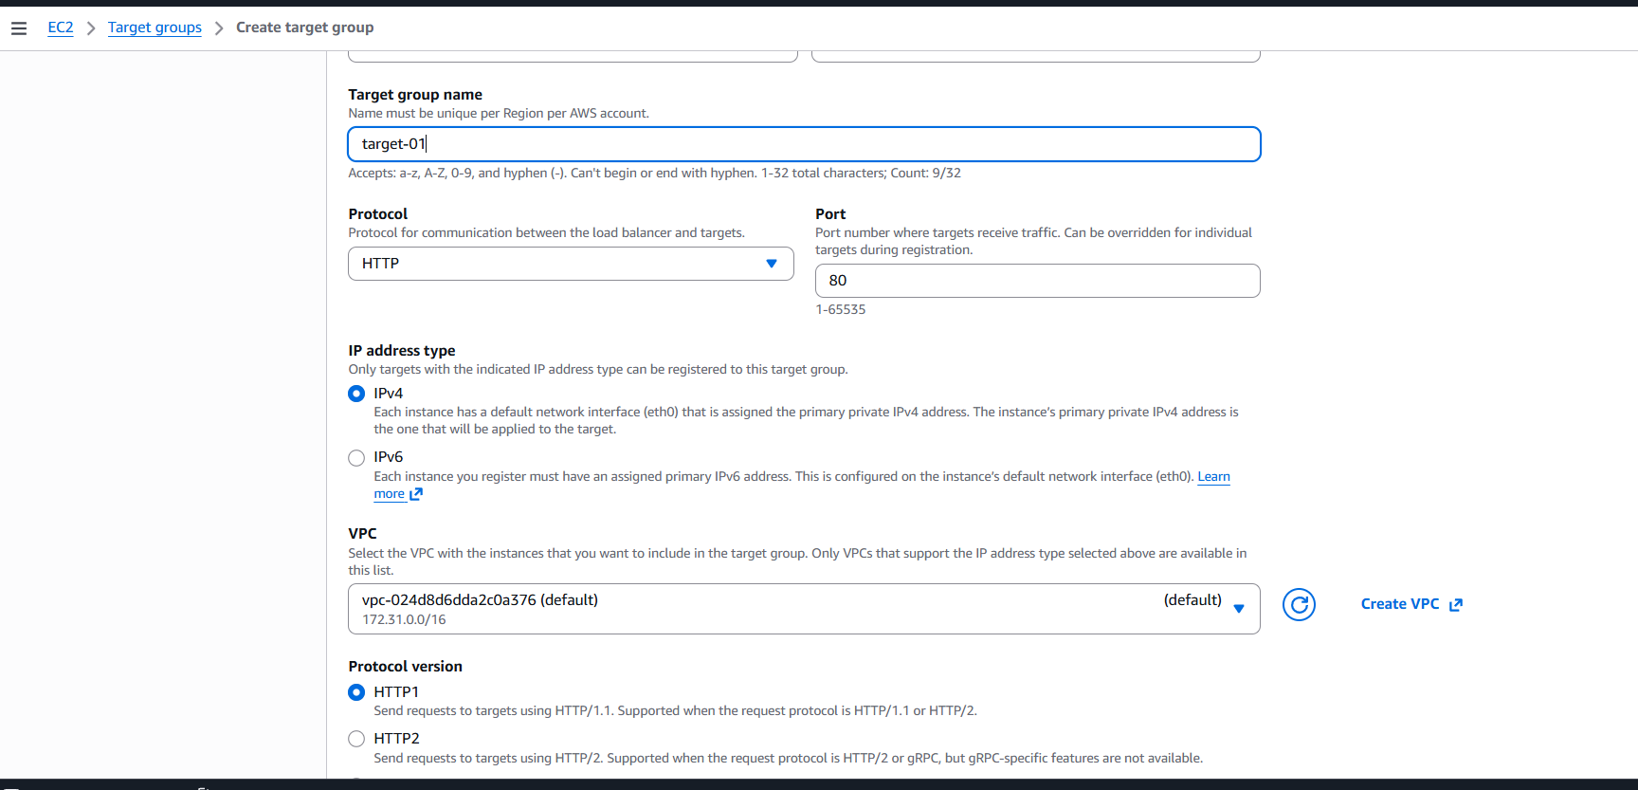
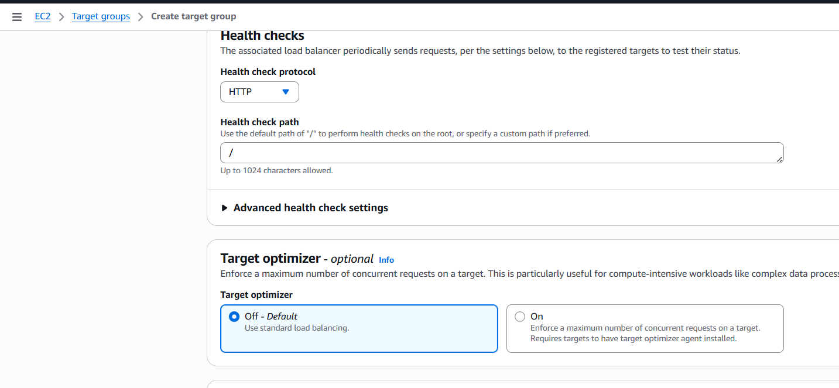
Register Target
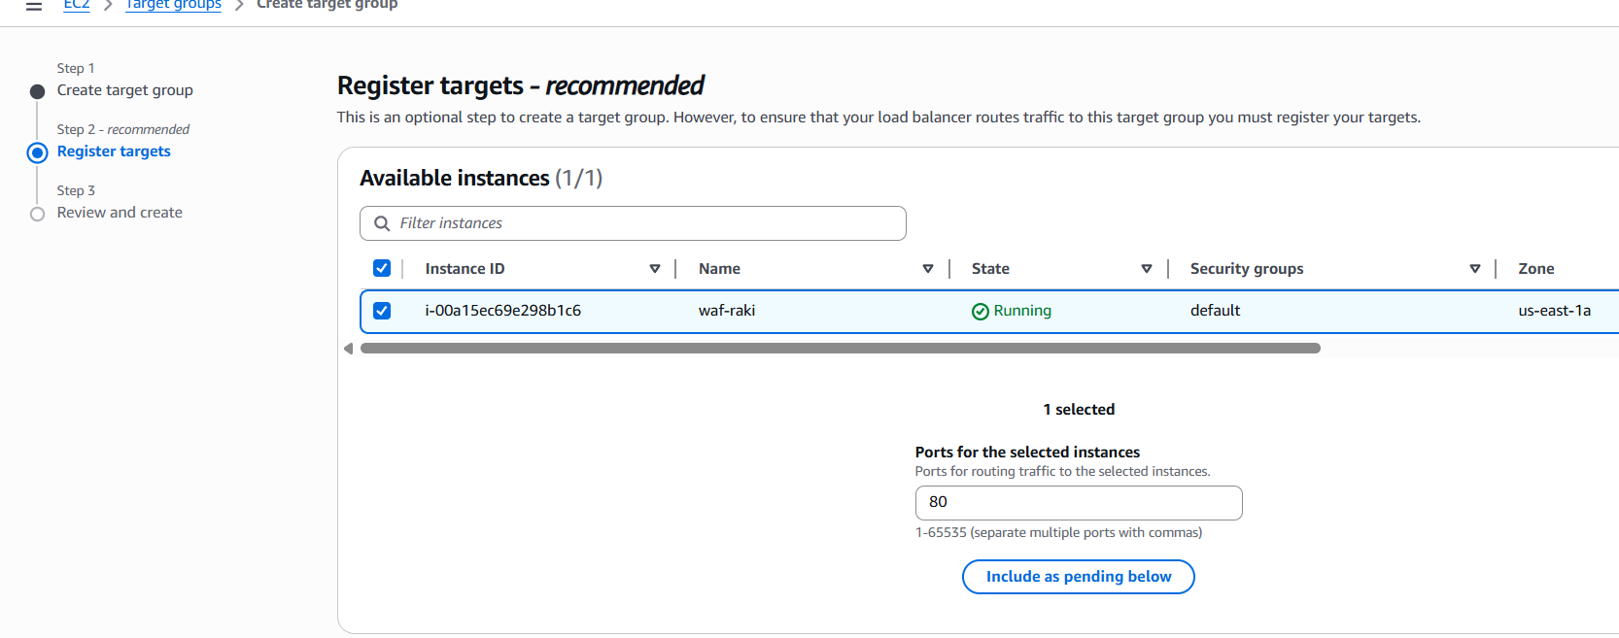

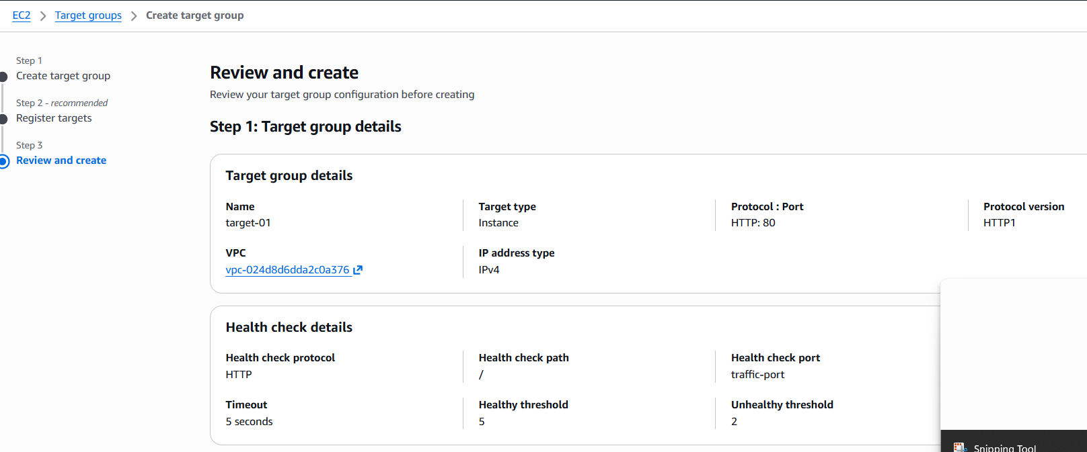
Create load balancer
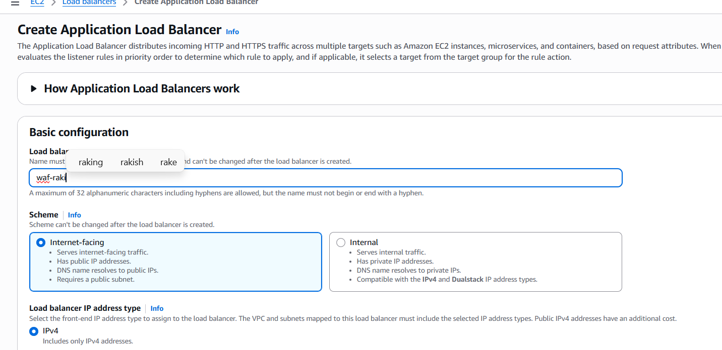
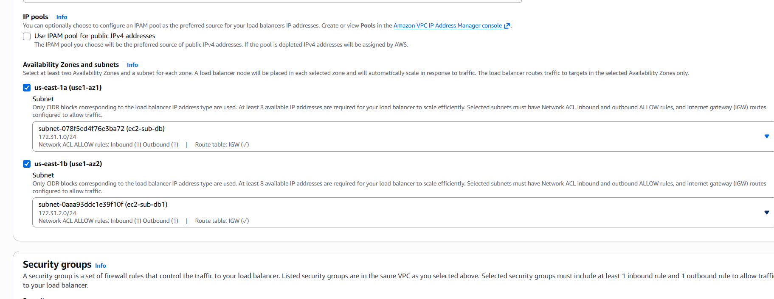

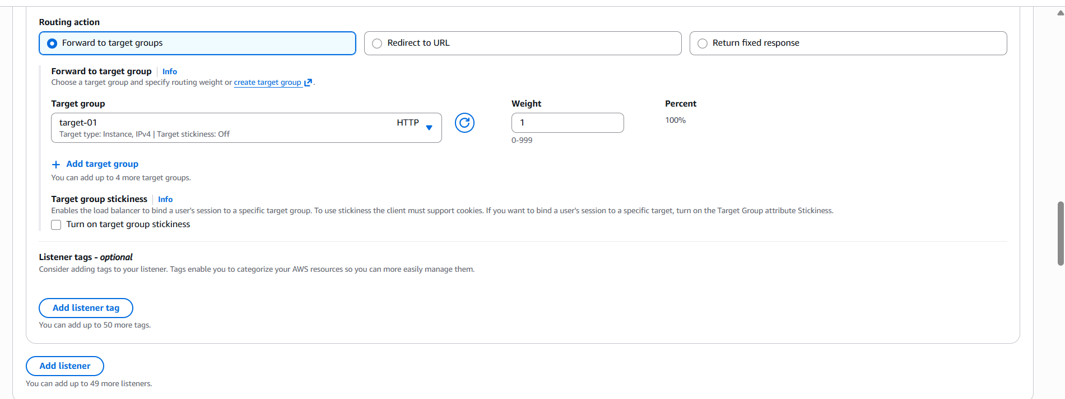
Load balancer is created
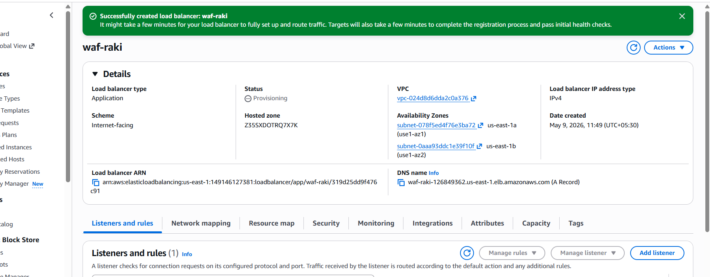

Load balancer is working
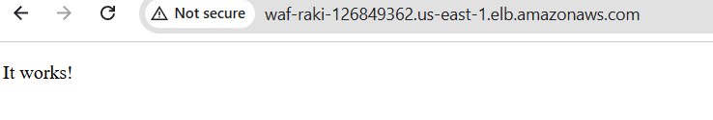

Create AWS WAF
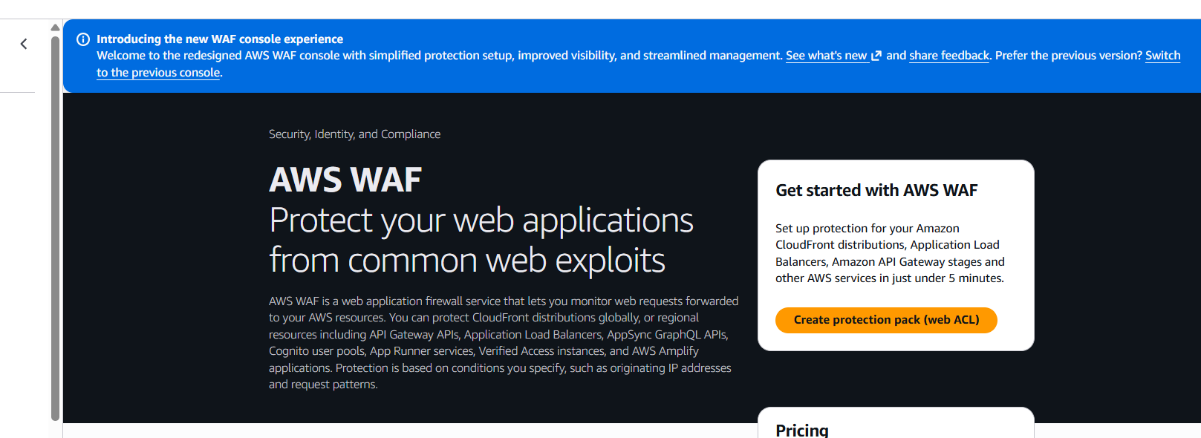
Click on create Web ACLS (Protection pack)
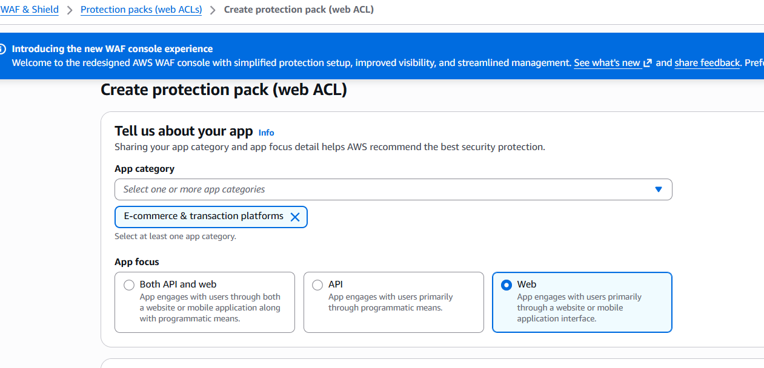
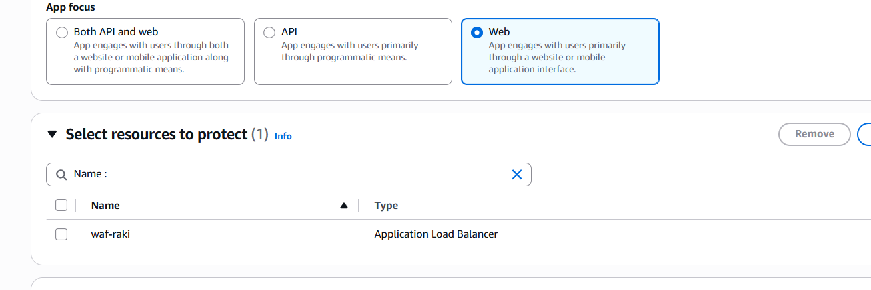
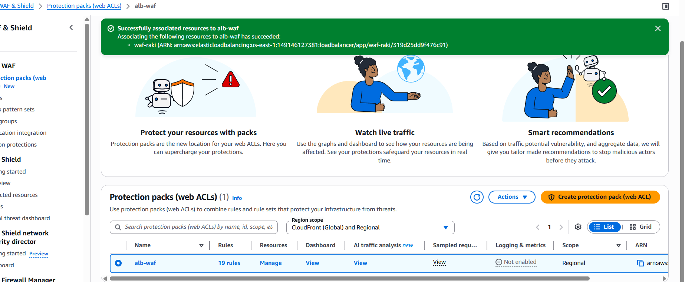
We are able to track the traffic
